**DAILY ONLINE ACTIVITIES SUMMARY**

|  |  |  |  |  |  |  |  |
| --- | --- | --- | --- | --- | --- | --- | --- |
| **Date:** | **30/05/2020** | | | | **Name:** | **Rohan Vashista BM** | |
| **Sem & Sec** | **6th Sem & B** | | | | **USN:** | **4al17CS078** | |
| **Online Test Summary** | | | | | | | |
| **Subject** | | **PAP Test2** | | | | | |
| **Max. Marks** | | **30** | | **Score** | | **12** | |
| **Certification Course Summary** | | | | | | | |
| **Course** | **SQL fundamentals** | | | | | | |
| **Certificate Provider** | | | **SoloLearn** | **Duration** | | | **3 hrs** |
| **Coding Challenges** | | | | | | | |
|  | | | | | | | |
| **Status: completed** | | | | | | | |
| **Uploaded the report in Github** | | | | **yes** | | | |
| **If yes Repository name** | | | | <https://github.com/Rohanvasista/Coding-activities> | | | |
| **Uploaded the report in slack** | | | | **yes** | | | |

**Online test details**

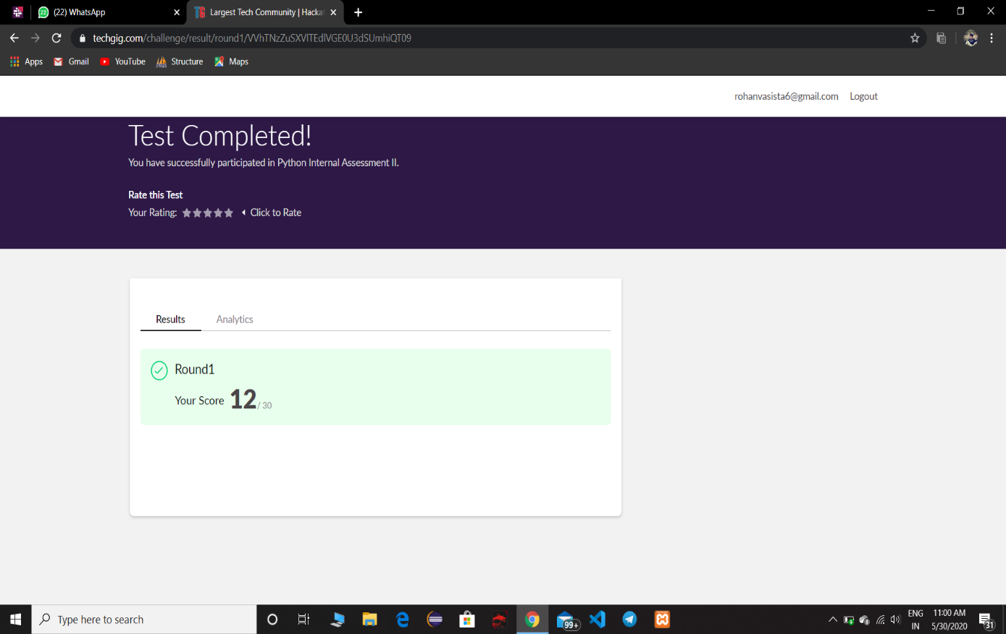

**Online Certification Details**

Completed modules

* SQL fundamentals
* Introduction
* SQL statements,syntax’s
* Selecting multiple columns
* DISTINCT and LIMIT
* QUIZ

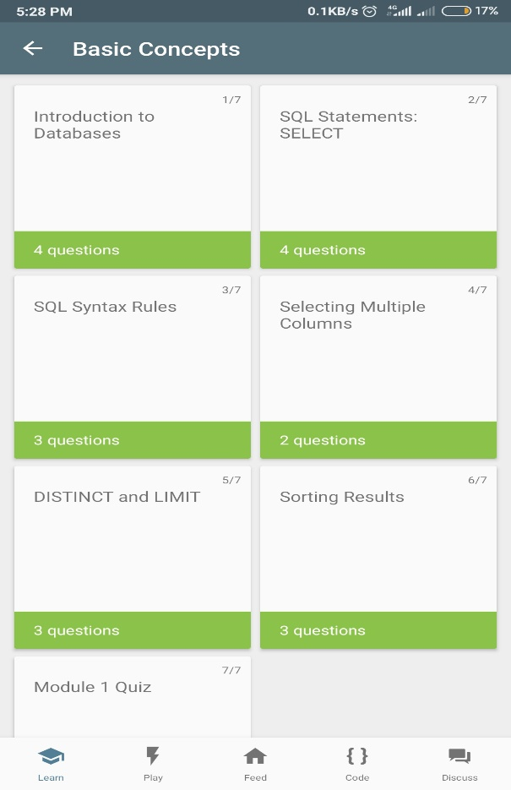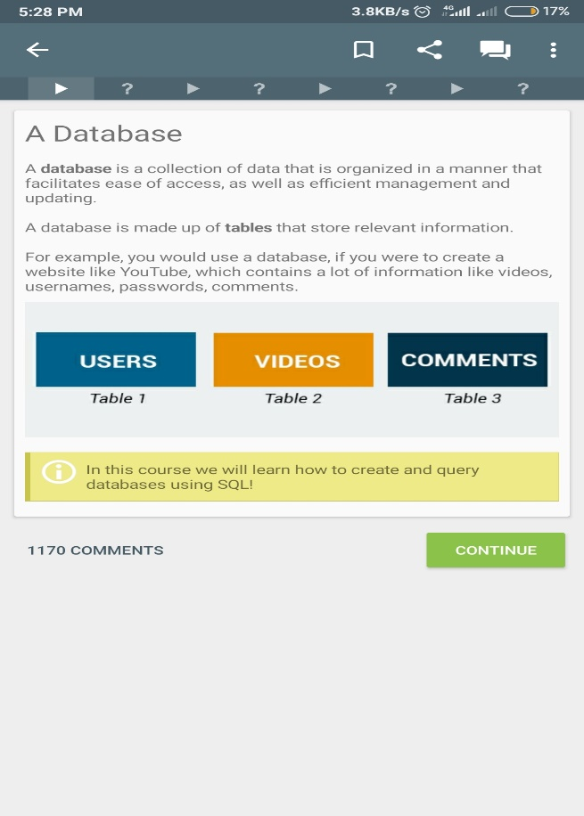

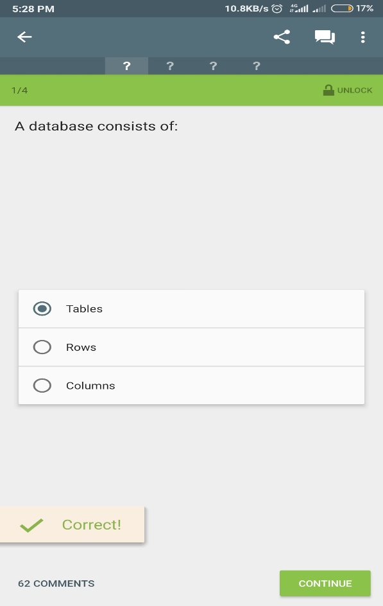 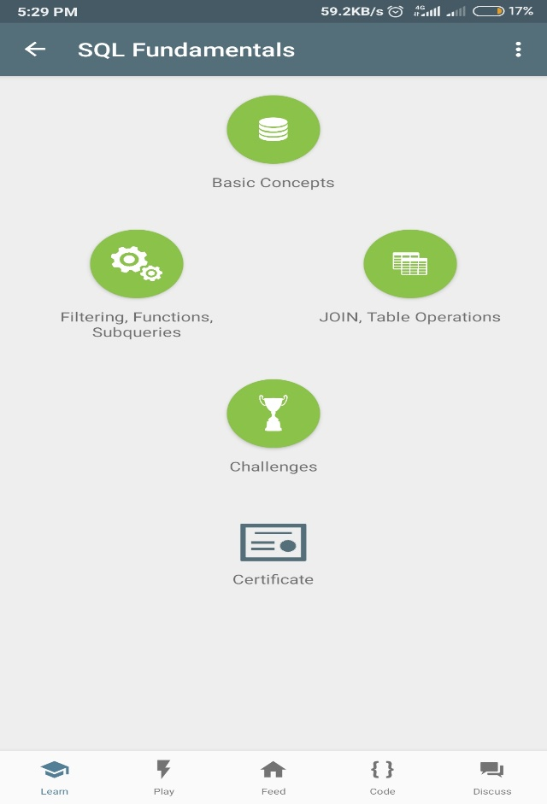

**CERTIFICATE OF COMPLETION**

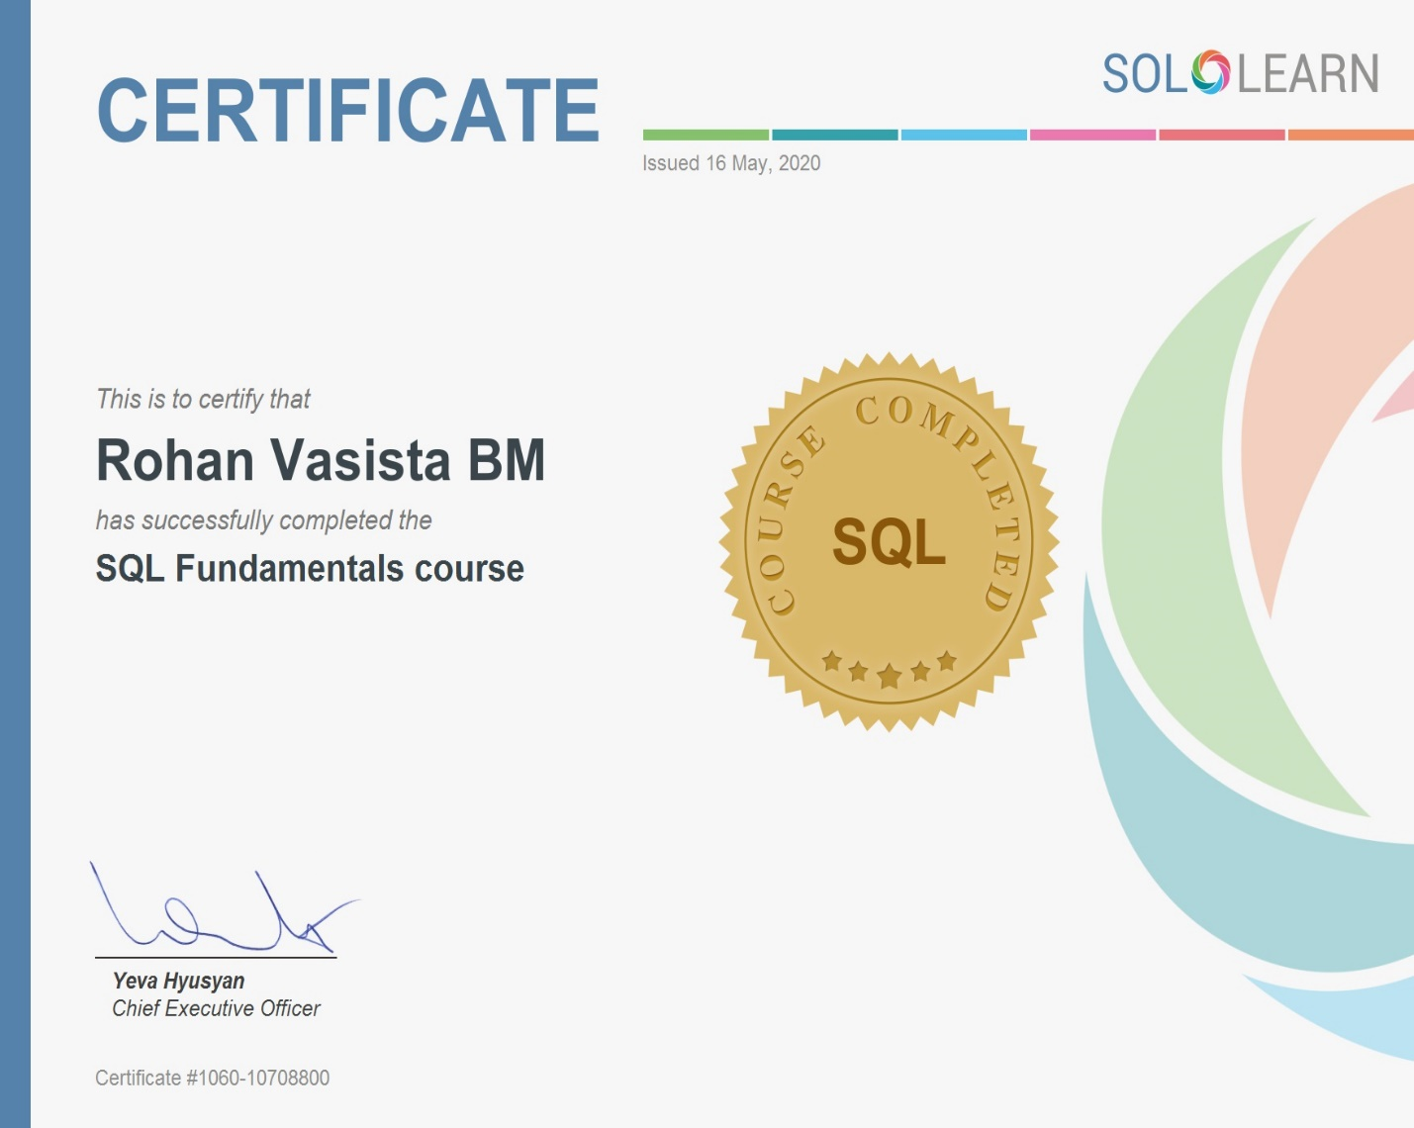

**Coding Challenge Details**

**1.** python program to read a number and print the pattern

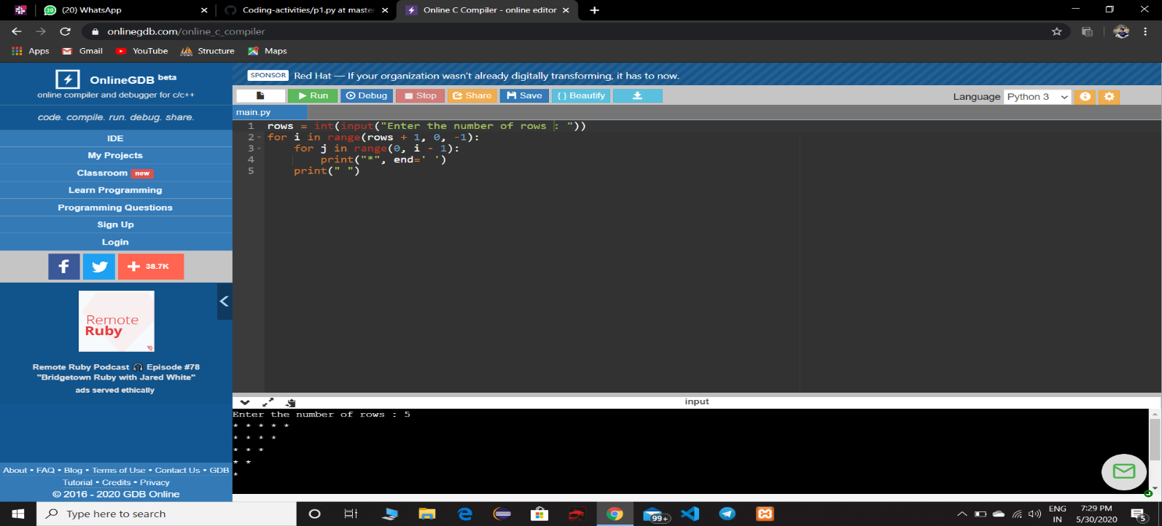

**2.** Java program to Count number of trailing zeros in product of array

